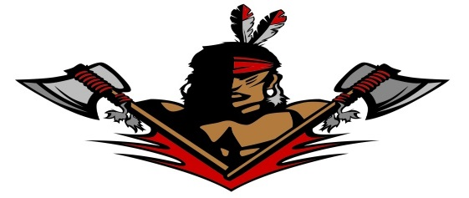
PORTAGE POP WARNER

SPONSORSHIP/DONATION FORM
We are pleased to support the Portage Pop Warner Football and Cheer program in Portage, Indiana. Pop Warner is a National Youth Sports organization and is classified as a 501 (c)(3) non-profit, so any donation made will be considered tax-exempt.

A financial donation in the amount of $_____________ has been included with this form in exchange for the sponsorship option indicated below:

_________ TOUCHDOWN SPONSORSHIP $400
- Logo and business information on a banner to be displayed at all home games.
- Link to sponsors business page on the PPW website for 1 year (The PPW website links with Northern Indiana, Regional, and National PW sites.)
- Link to business page for 1 year on the PPW social media pages for 1 year.
- Business name to be announced at all home games as an Official Portage Pop Warner sponsor.
- Plaque to be displayed in your business.
- Official Portage Pop Warner Sponsor

_________ FIRST DOWN SPONSORSHIP
- Link to business page on PPW website for 1 year. (The PPW website links with Northern Indiana, Regional, and National PW sites.)
- Link to business page for 1 year on the PPW social media pages for 1 year.
- Business name to be announced at all home games as an Official Portage Pop Warner sponsor.
- Plaque to be displayed in your business.
- Official Portage Pop Warner Sponsorship

Business Name/ Contact Person:___________________________________

Address:___________________________ City/State/ Zip:_________

Email:___________________________ Telephone:__________________

Please make CHECK or MONEY ORDER payable to PPW ( or Portage Pop Warner) and mail this form to : Portage Pop Warner Attn: Board of Directors, P.O. Box 80, Portage, IN 46368 OR call Rachel Jablonski at 219-771-7654 for donation drop-off.

PLEASE ATTACH WEBSITE LINK AND BUSINESS CARD FOR ADVERTISING PURPOSES.

